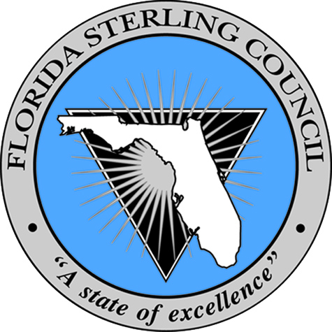
Governor’s Sterling Award & Sustained Best Practices

Title of Best Practice: “Workforce Recognition and Engagement Store”

Description of Best Practice:
The Walton County Tax Collector places a high importance on workforce engagement by identifying an engaged and empowered workforce as a strategic priority. An engaged workforce brings benefits to an organization in many ways from enhanced customer service to a culture of continuous improvement in all areas of operation. One practice incorporated by WCTC is through a peer to peer recognition system used to reward team members for positive behavior consistent with the core values of the organization. The recognition occurs through the delivery of a “High Five” or “Thumbs Up” card presented to the team member from another. Cards can not only be presented peer to peer but also supervisor to employee or vice versa. The cards, with an image of a high fiving hand or a thumbs up, have blank lines on the reverse side used to describe the core value aligned activity the team member performed. These cards can be collected by team members and used to purchase items from a team managed Workforce Engagement Store. Available in the store are items such as: can and water bottle koozies, visors, lunch coolers, cups and mugs, tote bags and blankets. The items are priced by number of cards required for purchase depending on the cash value of the items. The store is provided an annual supply budget to replenish inventories.

Results:
The Walton County Tax Collector’s workforce recognition and engagement store process has provided great results to the organization. The key result enhancement has been to overall workforce engagement levels which have risen from 93.2% in 2012 to 95.7% in 2013. Increased engagement levels among the workforce have led to a greater commitment to the organizations mission and higher levels of customer service and satisfaction.
Application:
To replicate this best practice, an organization should begin by empowering a team of the workforce to manage the recognition and engagement store. With an annual supply budget, the team can then select and purchase the items most desirable for the store and manage the process of recognition card disbursement.

