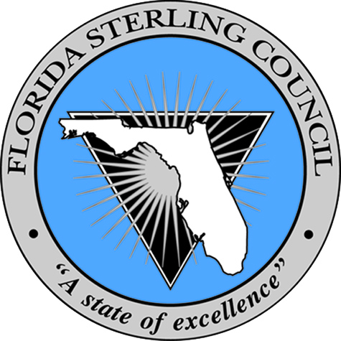
Governor’s Sterling Award & Sustained Best Practices

Title of Best Practice: “Workforce ICDPs and Individual Education Budgets”

Description of Best Practice:
Growth and continual learning is a very important part of the Walton County Tax Collector work culture. Whether there is a desire to advance or simply grow in the position currently fulfilled, all team members are encouraged to make learning a priority. To support this desired outcome, the Walton County Tax Collector’s office requires each team member to develop and update an ICDP (individual career development plan) each year which is then updated and reviewed semi-annually. Workforce ICDPs guide individuals through the process of establishing short and long term career goals. Learning objectives can consist of reading relevant books and articles as well as attending courses to develop skills and increase knowledge. In support of this process, the Walton County Tax Collector provides individual education budgets for each team member. The budgeted amount is established annually and varies based on a member’s position classification. The ICDP process ensures a culture of continual learning and sustains an organization through a knowledgeable workforce by empowering each individual with their professional and career development.

Results:
As a result of this practice the Walton County Tax Collector has seen positive workforce learning and engagement improvements. Training hours per team member has increased steadily since 2010 from 34.6 to 77.56 in 2013 and education funding utilized per team member has consistently met the target of $500 since 2010. Overall workforce engagement levels have also improved most recently from 93.2% in 2012 to 95.7% for 2013.
Application:
Other organizations can replicate this practice by incorporating a similar goal setting individual career development plan process. The individual plans should address long term and short term desired learning objectives driven primarily by the individuals. In support of the development plan, organizations can provide funding at the individual level by establishing individual training budgets. Organizations that adopt this practice can anticipate increased workforce engagement and a culture dedicated to continuous learning.

